TITANIUM DIOXIDE

RUTILE TITANIUM DIOXIDE－R878

Applications Plastic, masterbatch, Flexibility PVC, Rubber

Production
Description

Inorganic Al surface coating ，organic surface treating
Good glossiness ，good tinting strength,
strong hiding power, resist to atomize, and easy to disperse in plastic and rubber etc

Production Appearance

White powder

Item

Specification

Purity TiO2 % ≥ 96
Matter volatile at 105℃ %≤ 0.8
Hydrotrope % ≤ 0.5
Technical Residue on sieve 45 μm % ≤ 0.03
Data Color compare with standard Not lower than
Tinting strength compare with standard % ≥ 115
PH of suspension, aqueous solution retained 6.5-8.5
Oil absorption g/100g ≤ 18
Resistivity of aqueous extract Ωm ≥ 100
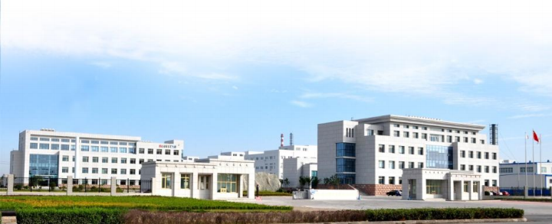
Rutile crystal form conversion， % ≥ 97.0

